 | Natural History Society of South Australia Inc  trading as  Wombats SA  Nomination Form for Management Committee Member Position 2024 | 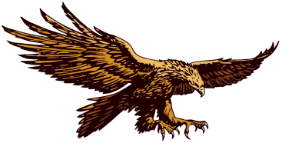
(Please print and sign)

No more than ten positions for Management Committee members are to be filled for one year until the next AGM. Executive Members of the Management Committee are to be elected from within those Members forming the Management Committee at their first meeting following the AGM on 6th April 2024.

I nominate (nominee): |  |  | as a Management Committee Member.
Nominator: |  |  | Signed
Seconded by: |  |  | Signed
I (name of nominee) |  |  | accept the nomination above.
Signed (nominee) |  |  | Date

PLEASE NOTE: NOMINATIONS TO BE RECEIVED BACK BY 30th MARCH 2024.
Post to Wombats SA Secretary, PO Box 410, BLACKWOOD SA 5051 or scan & send to: info@wombatssa.org.au.
The list will be posted on the website (wombatssa.org.au) one week before the AGM and a copy provided at the AGM.
All nominators, seconders and nominees must be financial members of Wombats SA / NHSSA Inc.

Natural History Society of South Australia Inc
trading as
Wombats SA
Nomination Form for Management Committee Member Position 2024
(Please print and sign)

No more than ten positions for Management Committee members are to be filled for one year until the next AGM. Executive Members of the Management Committee are to be elected from within those Members forming the Management Committee at their first meeting following the AGM on 6th April 2024

I nominate (nominee): |  |  | as a Management Committee Member.
Nominator: |  |  | Signed
Seconded by: |  |  | Signed
I (name of nominee) |  |  | accept the nomination above.
Signed (nominee) |  |  | Date

PLEASE NOTE: NOMINATIONS TO BE RECEIVED BACK BY 30th MARCH 2024.
Post to Wombats SA Secretary, PO Box 410, BLACKWOOD SA 5051 or scan & send to: info@wombatssa.org.au.
The list will be posted on the website (wombatssa.org.au) one week before the AGM and a copy provided at the AGM.
All nominators, seconders and nominees must be financial members of Wombats SA / NHSSA Inc.

